**Methods Test 3 2018**

**Set Notation, Probability**

**Total Marks: 59 Time Allowed: 60 minutes**

**Name: _______________________**

**Part A: Resource Free Marks: 19**

**ALL** working must be shown for full marks.

**1.** **[2, 2, 2 = 6 marks]**

An experiment consists of drawing a number at random from {1, 2, 3, 4, 5, 6, 7, 8}.

Let A = {1, 2, 3, 4}, B = {1, 3, 5, 7}, and C = {4, 6, 8}.

a) Are A and B independent?

b) Are A and C independent?

c) Are B and C independent?

**2.** **[2 marks]**

If P(A) = 0.66, and P(B) = 0.8 and $P\left(A∪B\right)=0.528$, calculate $P(A∩B)$.

**3.** **[2, 2 = 4 marks]**

The probability that a married woman watches a certain television show is 0.4, and the probability that her husband watches the show is 0.5. The television viewing habits of a husband and wife are clearly not independent. In fact, the probability that a married woman watches the show, given that her husband does, is 0.7. Find the probability that:

a) both the husband and wife watch the show

b) the husband watches the show given that his wife watches it.

**4.** **[2, 2, 3 = 7 marks]**

Expand each of the following using the binomial theorem:

a) ${(x+2)}^{4}$

b) ${(3-2x)}^{3}$

c) the coefficient of $x^{5}$ in the expansion of ${(2x-1)}^{7}$

**Methods Test 3 2018**

**Set Notation, Probability**

**Total Marks: 59 Time Allowed: 60 minutes**

**Name: _______________________**

**Part B: Calculators Allowed Marks: 40**

**ALL** working must be shown for full marks.

**5.** **[5, 2, 3 = 10 marks]**

In a certain town, the probability that it rains on Monday is 0.21. If it rains on Monday, then the probability that it rains on Tuesday is 0.83. If it does not rain on Monday, then the probability of rain on Tuesday is 0.3.

a) Draw and label a tree diagram.

For a given week, find the probability that it rains:

b) on both Monday and Tuesday

c) on Tuesday

**6.** **[2, 3 = 5 marks]**

Three students are to be chosen to represent the class in a debate. If the class consists of six boys and four girls, what is the probability that the team will contain:

a) exactly one girl

b) at least two girls?

**7.** **[5 marks]**

Mrs Hollis decides to sit the eight students in her class in a long row. Callum and Christine do not want to sit apart. Mrs Hollis agrees that she will sit them with no more than two people between them. If Mrs Hollis changes the seating arrangements each day, how many days can she sit Callum and Christine no more than two people apart before she has to repeat the seating plan?

**8.** **[ 2, 1, 1, 2, 2 = 8 marks]**

The numbers in the Venn Diagram below indicate the number of fish in each of the sets A, B, and C. If one fish is chosen at random from the universal group, U, determine:

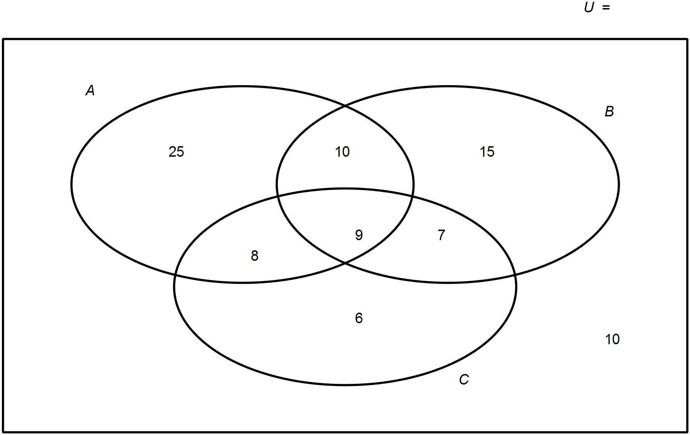

a) P(A)

b) P(A U B)

c) P(A ∩ B ∩ C)

d) P(A| (B ∩ C))

e) $P(A|(\overline{B ∩C)})$

**9.** **[1, 2, 2, 3, 4 = 12 marks]**

Five digit phone numbers are to be formed using numbers 0 to 9 inclusively. All phone numbers for south of the river are to be odd and all phone numbers north of the river are to be even. Find:

a. How many combinations for south of the river if digits cannot be repeated.

b. The probability of choosing north of the river if the digits can be repeated.

c. How many combinations for north of the river if the digits can be repeated and must start and end with an even number.

d. The probability of choosing south of the river if the digits cannot be repeated, the first digit is to be even and the end digit is to be odd.

e. The phone company decides to not distinguish between the north and south of the river, but instead to form numbers that are greater than 60 000 or end with an odd digit. The digits cannot be repeated. Find the number of combinations.